Autumn Update

Contents:
- Autumn Update
- Action on Water
- Watercress: A dying industry
- The government’s Planning Consultations
- The environment post-Covid
- Other developments in Bucks
- Rewilding
I hope you managed to get outside and enjoy the wonderful Buckinghamshire countryside this summer. Like most people we have had to work in a different way at CPRE Bucks. We have been holding all our meetings online and this has enabled us to continue to deal with a very busy agenda. The proposed changes to the planning system and the associated consultations are taking up a lot of our time and details can be found later on in this newsletter.

We have now gone live with our new website www.cprebucks.org.uk so please take a look. It is early days and we will be adding more content. On the front page of our website is a link to our new Vision for Buckinghamshire which sets out in one place what we think our priority areas of work should be going forward over the next few years.

In view of current Covid 19 situation, our AGM this year, which will be held on 17th Nov at 2pm will only be attended by the current trustees, using virtual technology. Full details and voting information is on our website www.cprebucks.org.uk/getinvolved/events [Paula Buck, Chair]

Action on Water

Last summer, we included an article about the issue of maintaining water supplies while also protecting our chalk streams. Since then the topic of water supply has attracted more attention, not least because of the drought followed by record levels of rainfall across the country!
At the beginning of February, one of our volunteers represented the Buckinghamshire branch at a South-East Area Sustainable Water Resources Workshop which included representatives from across the CPRE network. They met to discuss what CPRE should do to address this issue and the findings were as follows:
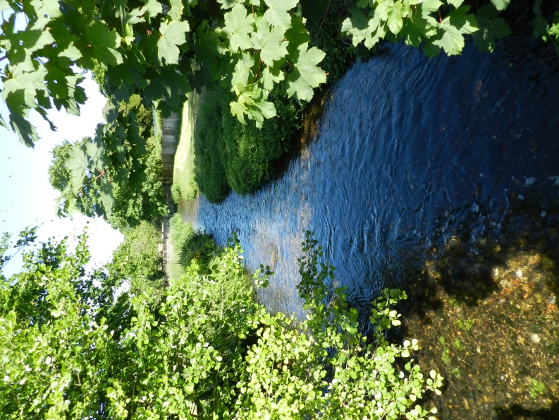
1.Background. Water companies operating in Buckinghamshire are Thames, Affinity and Anglian. Thames and Anglian water supply derives from surface water abstracted from rivers or reservoirs, whilst 90% of the Affinity SE area water supply is abstracted from Chalk boreholes. The Environment Agency (EA) assessment of water stress across the UK classified both the Anglian Water and Thames Water supply regions as areas of "serious" water stress.
2.Waste. Water Quality Assessments (WQA) across Buckinghamshire revealed that the capacity for treating waste water was deteriorating, with an increase in discharging untreated waste water into rivers and streams.
3.Climate Change. None of the WQAs considered climate change in their models.
4.Chalk streams. In 2013 the EA found that 77% of the English chalk stream water bodies tested failed the 'Good' quality criteria, while 30% were classified as in 'Poor' or 'Bad' state.
The main issues leading to failure were physical modifications/land drainage (34%), groundwater/surface water abstraction (24%) and pollution (30%).
To meet the increasing demand from population growth, plus greater extremes of drought and flooding, Affinity and Thames are proposing to construct a new storage reservoir in Oxfordshire. Known as the South-East Strategic Reservoir (SESR) it will be operational by 2037. CPRE Bucks oppose this proposed reservoir. While our priority is to protect the chalk streams by substantially reducing abstraction from them (even eliminating it altogether), we think our goal can be achieved by a combination of other, more environmentally-friendly schemes. These include implementing an existing, but much delayed, scheme (known as “Supply 2040”), fully utilising the supply from existing reservoirs, more efficient wastewater recycling , greater reductions in leakage and reductions in demand. With these – and other possible measures that we understand are already being considered, such as transferring water from the Severn – we believe the SESR would be unnecessary. Building a massive reservoir with 30m high embankments and destroying a huge area of good quality farmland seems to us to be the least environmentally attractive option and should be avoided at all costs.
As a group, the workshop agreed that CPRE will seek to engage more closely in the debate and stand up for the natural resources. [Tiina Sivori, Volunteer]

Chess Valley Watercress – Under threat from Thames Water
As many CPRE members are aware, the Chess Valley is an Area of Outstanding Natural Beauty (AONB) and features one of Europe’s finest chalk streams, the River Chess, along its length of almost ten miles. The valley offers an ideal opportunity for walkers, families and riders to enjoy the countryside – especially from the nearby towns of Chesham and Amersham. The Chess Valley also has excellent public transport links to London – it is possible to make a round trip from Rickmansworth to Chesham, for example, using London Underground’s Metropolitan line.
Chesham and Rickmansworth both boasted commercial watercress beds that also made use of the Metropolitan line. The watercress industry thrived in the Victorian era and now the village of Sarratt, on the border of Buckinghamshire and Hertfordshire, is home to the last of the watercress beds: Crestyl Watercress remains a family business, founded in 1886 by the current owner’s great-grandfather and
farming watercress from gravel beds set in channels running alongside the river Chess itself.
Sadly, following a further incident of sewage discharge into the Chess by Thames Water this September (one of many over the years), the contamination of this last remaining viable watercress business was so severe that the 2020 harvest cannot be sold for public consumption, with permanent closure of the Crestyl business a likely outcome.
CPRE supports rural businesses in Bucks – in this instance Thames Water have destroyed the viability of this important local business as well as causing yet more irreparable damage to a rare chalk stream.
CPRE Bucks urge our members to write to their MP, the Environment Agency and Thames Water to object to this violation of the AONB, which affects wildlife and people alike. [Andrew Garth, Trustee]
[Picture taken from Crestyl Watercress Facebook page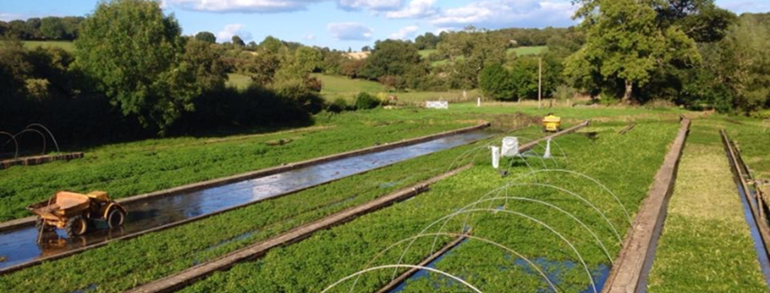

The Planning White Paper and Short-Term Changes to the Existing System

This August, the government published two documents for consultation. The first was a Planning White Paper setting out radical proposals for planning in England (planning is devolved to Wales, Scotland and Northern Ireland). The publication of the National Planning Policy Framework (NPPF) in 2019 was the biggest overhaul of planning for decades. But the NPPF merely rewrote the planning rule book. This White Paper shreds the rule book and introduces a radical approach to planning.
There are welcome points in the White Paper. A digital planning system. Simpler, quicker local plans. Strict design codes. But the government’s intention of diminishing the voices of council and communities in decision making is unwelcome. Ministers want a tick box planning system where rules are binding on decision makers. They also want huge increases in housebuilding – a near doubling of current targets in the South East.
The second consultation is on proposals to make changes to the existing planning system to pave the way for the approach described in the White Paper. These are also extremely concerning.
CPRE is already fighting the unwelcome elements of the White Paper and the shorter-term changes. Our Chief Executive, Crispin Truman, the Chair of our Policy Committee and a Branch representative from CPRE Hampshire met Robert Jenrick MP to express our concerns and, by the time you read this, a virtual round-table discussion between all CPRE branches and Robert Jenrick will have also been held. I am representing CPRE Bucks and we will report back on that in the next Newsletter. I think this shows the seriousness with which CPRE is taken in central government and hopefully will make a real difference to the proposals. [Neil Salisbury Trustee – Head of Planning]

Refocussing on the Environment post-Covid
There has been a surge in appreciation for green spaces and community spirit in South East England during the lockdown. A poll commissioned by CPRE and the National Federation of Women’s Institutes found nearly two-thirds (63%) of respondents think protecting and enhancing green spaces should be a higher priority after the lockdown.
National results. Only 11% of respondents felt less connected to their community during lockdown, while 40% felt more connected. One in three (33%) of 18 to 34-yearolds say they have made new intergenerational connections. Over half (54%) agree that people are doing more to help their communities. Nearly two-thirds of people (63%) feel protecting local
green spaces should be a higher priority for the government when lockdown ends. South East. Only 8% felt less connected to their community at this time – 46% felt more connected and 40% just as connected as before. Over half (56%) of those in the region agree that people are doing more to help their community under lockdown. 68% of people want their local green space to better protected, while 59% say they appreciate local green spaces more since the country adopted social distancing measures. Almost two thirds (63%) say the lockdown has made them more aware of the importance of local green spaces for mental health and wellbeing. Almost half of those in the region (42%) reported visiting green spaces more during lockdown. [Neil Salisbury Trustee – Head of Planning]

Other Developments in Buckinghamshire

With the advent of the Unitary Buckinghamshire Council – but with elections delayed until next year – the Council have moved to a compass-based organisation for planning. There are now planning committees for North, South, East, West and Central Buckinghamshire, replacing the three District Councils’ planning committees. Overall responsibility for Planning and Enforcement in Bucks is with Cabinet Member Councillor Warren Whyte. CPRE Bucks looks forward to working with the Bucks Council planning team on developing a new, single Local Plan for the whole County which we hope will recognise how the world has changed since the District-level Local Plans were written, even those that have only recently been adopted. In particular, CPRE Bucks will be campaigning to seek to ensure the countryside is protected and enhanced by the new Plan, that national commitments to a zero-carbon future are followed through and that changes in patterns of work, shopping and living are reflected.
In Milton Keynes, their Local Plan (Plan:MK) was formally approved last year, but has already come under threat after a government planning inspector decided that Milton Keynes Council could not prove it had a supply of housing land for five years (every council must have a five year land supply or developers can take the initiative to fill the gap). However, in June, the Secretary of State concluded that the Council could demonstrate a five-year housing land supply and dismissed an appeal from a major developer. While this is good news, there is no doubt that the pressures on the countryside are still there and are not going away [Neil Salisbury Trustee – Head of Planning}
CPRE Regeneration Campaign – Wildlife and Rewilding

Recently Berks, Bucks and Oxon Wildlife Trust ran a series of webinars to encourage positive steps for wildlife in local parishes. BBOWT collaborated with a number of partners to support parish councillors, clerks and volunteers to discover how they can improve the local area for wildlife and residents. Hosted by the BBOWT in collaboration with the Buckinghamshire and Milton Keynes Natural Environment Partnership and the Chilterns Conservation Board, each webinar focused on a specific topic offering information and advice about how you can manage areas and green spaces for wildlife. The topics covered were: Local planning with biodiversity and wildlife in mind; Road Verges and meadow management; Hedgerows and woodland management; Pond Management; Engaging the local community. The contributors were from a wide variety of organisations such as Plantlife; Bucks Buzzing; Bucks and MK Environmental Records among others.
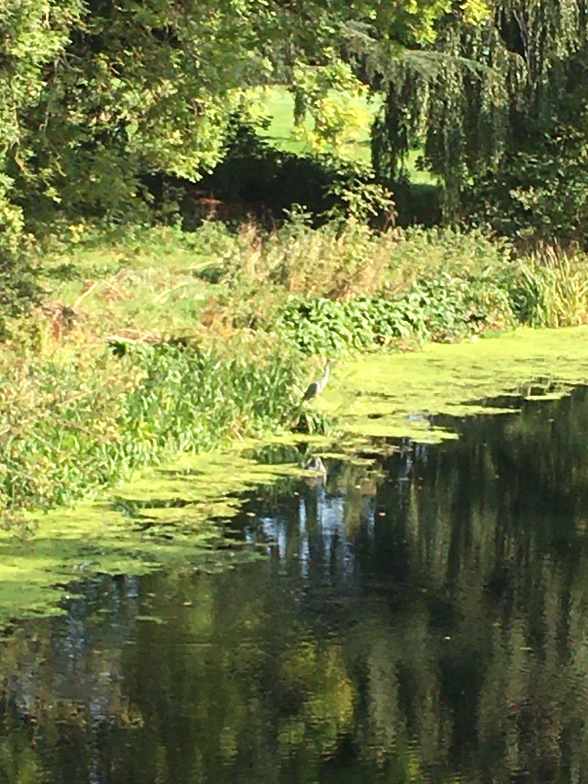

We attended these webinars to learn from what others have done, and then apply this to our own activities through our volunteer network. There were many examples of projects such as creating wildflower areas on road verges in villages, wildlife ponds in schools, hedgerow management in areas of parks and recreation grounds, ways of encouraging hedgehog and other wildlife survival, that we could be involved with. But, to do this we would need volunteers committed to such projects in their local area.
As with any activity or campaign there are a variety of views, varying from enthusiastic support to outright opposition. The webinars did cover some of the problems they encountered – local residents mowing wildflower verges by torchlight, as they preferred a manicured grass area in front of their house; goldfish being released into newly created wildlife ponds; newly planted saplings being uprooted, etc. However, the enthusiasm of the majority in each community, for the improvements being made to their environment, overcame these. An enthusiasm we wish to encourage.
Perhaps you are already involved in such activity, or have been considering doing it, if so let us know. In this way CPRE Bucks can make a real practical contribution to the national regeneration campaign. [Steven Horner Treasurer}

For more information please visit our website www.cprebucks.org.uk or contact us at office @cprebucks.org.uk

